A000-AM,C-Nicaragua-Rivas Dept.-Greater Nicoya-Figure-Female-Polychrome-

MASTER

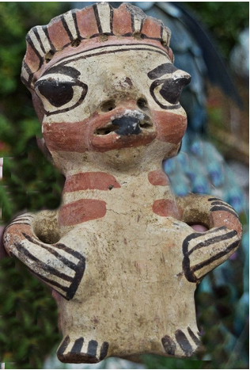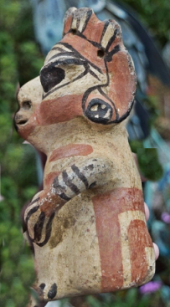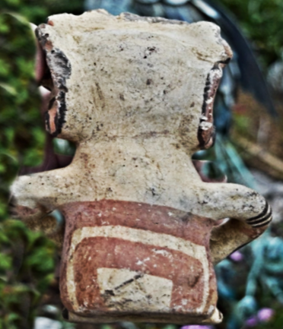

Nicoya female figurine from Rivas Department, Nicaragua.   
  
  
Rivas Department, Nicaragua, borders Lake Nicaragua to the east and the Pacific Ocean to the west. The southern part of the department borders with Costa Rica.

**Formal Label:**

**Accession Number:**

**Date or Time Horizon:**

**Geographical Area:** Rivas Department, Nicaragua

Map:

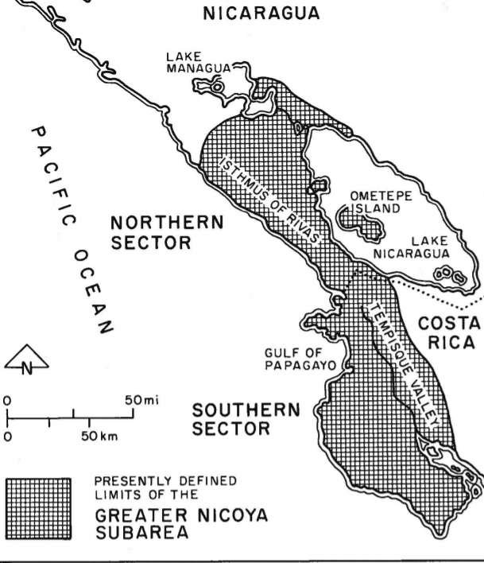

THE ARCHAEOLOGICAL SUBAREA OF MESOAMERICA originally defined as "Greater Nicoya" (Fig. I) by Norweb (1964) is divided into a "northern sector," which corresponds to Pacific Nicaragua as far north as Managua, and a "southern sector," which generally corresponds to the Nicoya Peninsula in Costa Rica (Lange 1984a).

GPS:

**Cultural Affiliation:** Nicoya

**Medium:** buff terracotta

**Dimensions:**

**Weight:**

**Provenance:** part of my collection found at an estate sale in Pasadena years ago professionally cleaned, no repairs or repainting, slight damage to crown from the estate of movie director Michael Cimino

**Cultural Affiliation:** Nicoya

**Media:** terracotta, clay slip, red and black pigment.

**Dimensions:**

**Weight:**

**Provenance:** from the estate of movie director Michael Cimino.

**Dimensions:**

**Weight:**

**Condition: Original.** Some spalling on the surface shows the effects of moisture in the grave,

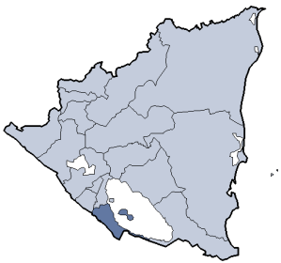

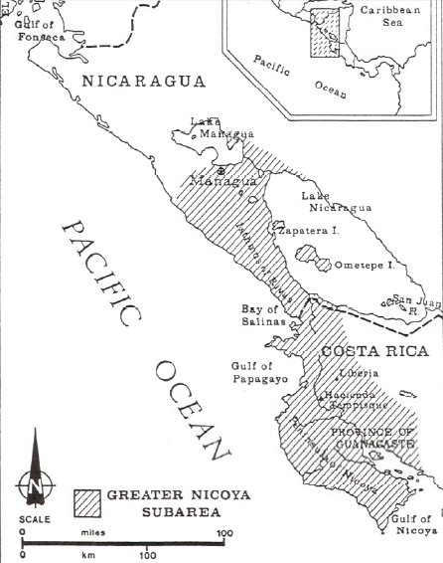

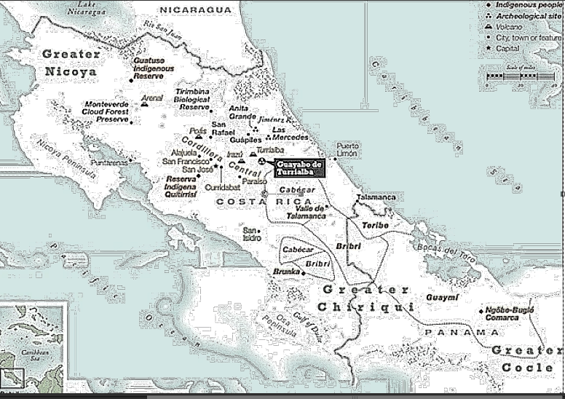

Discussion:

This elaborately-painted, carefully hand-modeled seated female nude ceramic figure is portrayed with polychrome brown-on-cream-colored linear and geometric body art and tattoos covering her shoulders and chest. She is posed standing with both hands akimbo.

Guanacaste-Nicoya archaeological periods follow the periodization of Lower-Central America (Lange 1996) in six periods that spanned 12,000 BCE-1550 CE/AD. This polychrome ceramic comes from **Period V** (CE/AD 500-1000) in which there was a return to exploitation of marine resources, expanding habitations, and the development of Guanacaste-Nicoya polychrome ceramics of which this is an example in the Papagayo style: a cream-colored ceramic with polychrome motifs, which was widespread after 700 CE/AD. This ceramic with the figure’s eyes closed as if in a trance suggests she is one of the ritual specialists with shamanistic powers. It was probably placed in a grave in the Linea Vieja region where juxtaposed graves have stone-lined rectangular walls and floors that have preserved many ceramics in good to excellent condition (Stone 1972: 27).

**References:**

Abel-Vidor Suzanne, Dirk Bakker, Detroit Institute of Arts, Jay I. Kislak. 198. *B****etween continents/between seas: Pre-Columbian art of Costa Ri*ca.** New York: H.N. Abrams; [Detroit]: Detroit Institute of Arts.

Evans Toby, Susan and David Webster, eds. 2001. *Archaeology of Ancient Mexico and Central America: an Encyclopedia*. New York: Garland Publishing.

Lange, Frederick W., ed. 1996. *Paths to Central American Prehistory*. Boulder: University of Colorado Press.

Stone, Doris. 1972. *Pre-Columbian man finds Central America: the archaeological bridge*. Cambridge: Peabody Museum.

*Arts précolombiens de l’Amérique centrale dans les collections du musée Barbier-Mueller de Barcelone: Nicaragua, Costa Rica et Panamá,* 2001, cat. 9, p. 163